Contents

1 Revision History 3

2 Contributors and Key Stakeholders 3

3 Glossary 3

4 Scope 3

5 Managing objectives in Hansoft 4

5.1 Creating an objective 4

5.2 Assigning Business Value to objectives 5

5.3 Program Increment objectives report 5

5.4 Program PI objectives 6

5.5 Capacity allocation, velocity & load 6

6 Managing identified risks in Hansoft 7

6.1 Creating an identified team risk 7

6.2 ROAMing a identified team risks 8

6.3 ROAM report 9

7 Conducting the "Walk the Walls" procedure in Hansoft 10

8 DBT workspace board in Hansoft 11

8.1 DBT Team backlog requirements 11

8.1.1 Milestone property requirements 11

8.1.2 Planned sprint property requirements 12

8.2 DBT Team Workspace board configuration 13

8.2.1 Accessing a DBT team workspace in Hansoft 13

8.2.2 Customizing the DBT Team workspace size 15

8.2.3 Customizing the information that is displayed on the board item 16

8.3 General Board view functionality 16

9 Program Board in Hansoft 17

9.1 Program backlog requirements 17

9.1.1 Milestone property requirements 17

9.1.2 Planned sprint property requirements 17

9.1.3 Feature Lead property requirements 18

9.2 Visualizing program dependencies 20

10 Inspect & Adapt 21

10.1 Quantitative Measures 21

# Revision History

|  |  |  |  |
| --- | --- | --- | --- |
| Date | Revision | Description | Authorized By |
| 2015-11-27 | 1 | First document revision released on GitHub | Nicolai Ryvers & Patrik Hartlén |

# Contributors and Key Stakeholders

|  |  |
| --- | --- |
| Representing Competence/Domain | Name |
| Release Train engineer | Nicolai Ryvers |
| Hansoft customizer | Patrik Hartlén |

# Glossary

|  |  |
| --- | --- |
| Abbreviation | Meaning |
| RPE | Release Planning Event |
| PI | Program Increment |
| SMART | Specific, Measurable, Attainable, Realistic, Timely |
| DBT Team | Design/Define, Build Test Team |
| I&A | Inspect & Adapt |

# Scope

This document describes how to use Hansoft during a SAFe Release Planning Event, RPE, with the pre-requisite that Hansoft has been customized according to the instructions that are available here: <https://github.com/patrikha/Hansoft-Jean-Jean>

# Managing objectives in Hansoft

During the RPE each DBT team will define a number of SMART objectives that summarize the work they have planned for the Program Increment; PI. Both objectives and stretch objectives are defined with the assigned Business Value set by the Business Owners.

All objectives are created in the agile schedule view for the Program project. Where each team has an "Objectives" folder in the "Release planning event" section of the" Program PI x " sprint.

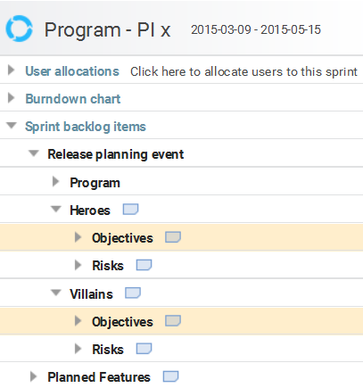

## Creating an objective

For each new objective, create a new "Sprint backlog item" in the "Objectives" folder. The item should be given a SMART name that summarizes the objective. If additional details are needed, this can be added in the "User Story" field; right the click the backlog item and select "Flag as a user story" to activate the user story field.

Each objective must be specified as a "PI Objective" or a "PI objective (stretch)" in the "Type" property.

 

The team name must also be set for each objective; this is done in the "Team" property.



## Assigning Business Value to objectives

As part of the RPE the Business Owners and Product Managers perform the "Walk the Walls" procedure where the objectives are reviewed together with the Product Owner and the DBT team.

The Business Owners then assign Business Value to all PI objectives and stretch objectives. The Business Value is set to a value between 1-10 and is set in the "Business Value" property.

Below is an example of a number of PI objectives and stretch objectives with assigned Business Value:

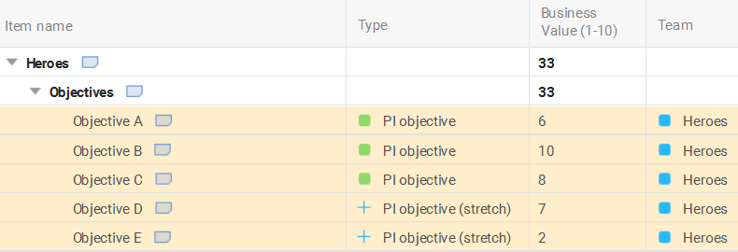

**Note**: See Conducting the "Walk the Walls" procedure in Hansoft for additional information on when business value is assigned.

## Program Increment objectives report

The "RPE PI x - Objectives" report has been created to provide an overview of all team objectives that have been defined for a PI. The report is grouped by Team and Type; *PI objective* or *PI Objective (stretch)*.

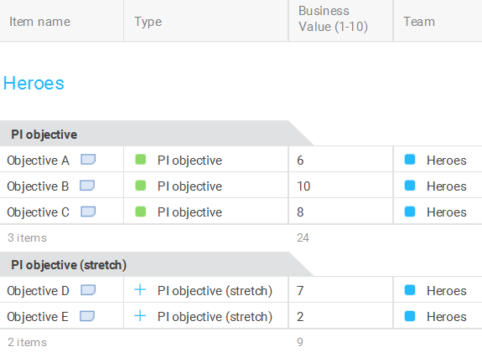

Example reports are available in the agile schedule toolbar in the Program project: 

## Program PI objectives

The Program PI objectives is a roll up of all the team PI objectives and are entered into Program “Objectives” foder:

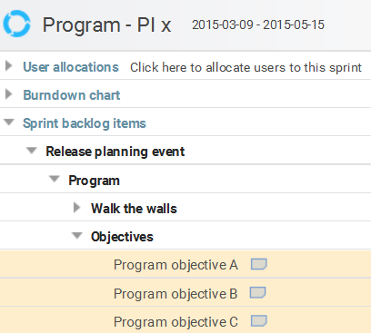

## Capacity allocation, velocity & load

The capacity allocation, velocity and load information for a team is entered in the "User Story" field for the team name folder. Exampled of capacity allocation categories are be:

* Technical Debt
* New development
* Future

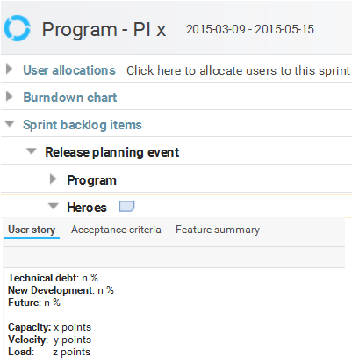

# Managing identified risks in Hansoft

As DBT teams are planning their work for the PI they may also identify risks associated to their plan. These risks can be categorized into either team risks or program risks.

* A team risk is something that the team may come across during the PI which the team can manage on its own or together with another team.
* A program risk is something that falls outside what the team can manage on its own, where the program as a whole may have to act in order to manage the risk.

Each DBT team enter identified risks in the team "Risks" folder in the "Release Planning Event" part of the"Program PI x " sprint.

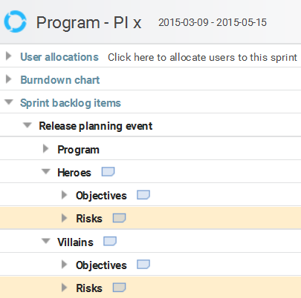

## Creating an identified team risk

For each identified risk, create a new "Sprint backlog item" in the "Risks" folder. The item should be given a name that summarizes the risk. If additional details are needed, this can be added in the "User Story" field; right the click the backlog item and select "Flag as a user story" to activate the user story field.

The "Team" property must also be set for each risk that has been identified. The team name should be entered for all team risks and "Program" should be entered for all program risks



## ROAMing a identified team risks

Each risk must be ROAMed which stands for *Resolved*, *Owned*, *Accepted* or *Mitigated*. This categorization is set in the "ROAMed" column.



Each risk can be categorized as:

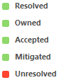

Add a comment in the comment field in order to clarify the risk and its ROAMed status.

Unresolved team risks may be escalated as program risks and be discussed during the draft/final plan review.

Below is an example of two program risks and four team risks that have been ROAMed:

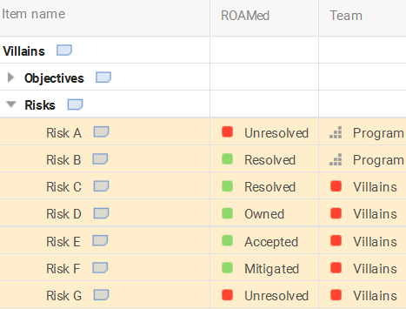

## ROAM report

The "RPE PI x - Risks" report has been created to provide an overview of all team risks that have been identified for a PI. The report is grouped by the "Team" property and ROAMed status; *Resolved*, *Owned*, *Accepted* or *Mitigated*.

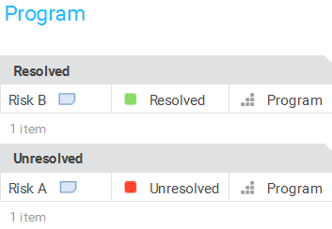

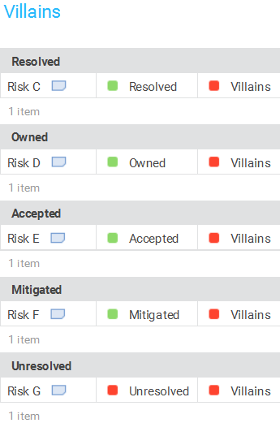

Example reports are available in the agile schedule toolbar in the Program project: 

# Conducting the "Walk the Walls" procedure in Hansoft

As part of the "Walk the Walls" procedure during the RPE, the business owners assign business value to team PI objectives. With distributed teams at the same location and/or remote locations, the order in which the teams are participating in the "Walk the Walls" procedure can be tracked in Hansoft.

In the example below you can see that the Heroes team is currently partaking in the "Walk the Walls" procedure and the Villains team still require the business owners to assign business value to their team PI objectives

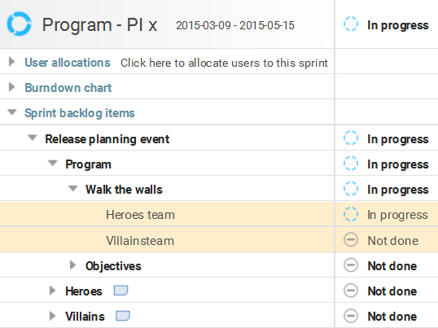

# DBT workspace board in Hansoft

During the RPE each DBT team is to produce a plan for how they will execute their work during the PI. Each team plan should be made available to everyone in the Program through the team workspace. In Hansoft the backlog "Board view" can be used to visualize the team workspace and the planned work.

**Note**: The "Board view" in the "Agile Schedule" cannot be used since this is used for execution of work and during the RPE we are planning the work, therefore the backlog "Board view" must be used.

## DBT Team backlog requirements

In order for the DBT team workspace to be visualized a number of properties must be set for each backlog item that is planned for the PI.

### Milestone property requirements

In each team project in Hansoft a milestone must be created for the PI. The pre-defined naming convention to be used is "PI x" and the date for the milestone should be the last day of the PI.

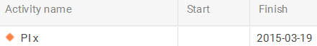

Each backlog item that is planned for the PI must be tagged with the "PI x" milestone in the "Milestone tag" property.



Milestones are also used to links backlog item from the team project to the Program backlog, in order to automatically aggregate the status to the program. Therefore a milestone must be created in the team project "Agile Schedule" for each architectural feature, business feature or spike that shall be linked to the Program. A rule of thumb is to have the same name for the milestone in the team project and the backlog item in the Program backlog. The link between the team project milestone and the program backlog item is created using the "Link to items" feature. The "Link to items" feature is enabled when the "Linked to Items" column is activated.

Right-click the milestone/backlog item and select  in the context menu. The next step is to right-click the backlog/milestone item and select  and the link has been created between the two.

**Note**: It's possible to multi-edit backlog items, but this is not recommended to do so for the "Milestone tag" property; unless the backlog items should have identical milestone tags.

The "Milestone tag" property is inherited, hence it's only necessary to tag the parent object and all child objects will inherit the milestone tag. Below is an example of a feature with both the *PI x* and *feature* milestone tags assigned, where it also has been inherited to all sub items.

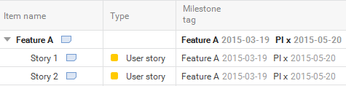

### Planned sprint property requirements

A feature should be broken down into one or more user stories/work items which are delivered in a number of sprints. The planned sprint for each feature and user story delivery must be specified in the "Planned sprint" property.



**Note**: Assigning the "Planned sprint" will only indicate the plan that is made during RPE.

A feature should be broken down to always fit within a PI. If a feature will require deliverables over multiple PI's, the feature sub items associated with a particular PI should be tagged with the appropriate milestone tag.

Below is an example of a team backlog where the "Planned sprint" and "Milestone tag" has been assigned to reflect the team plan.

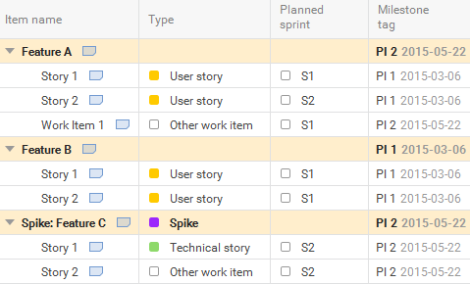

## DBT Team Workspace board configuration

In order to visualize a DBT Team workspace in Hansoft, the backlog "Board view" in the team project must be used.

For the workspace to be presented correctly the backlog items require a number of properties to be set which are described in 8.1 DBT Team backlog requirements.

### Accessing a DBT team workspace in Hansoft

First select the team project for which you want to view the workspace and open the team backlog view. In the top left corner of the team backlog view you can switch to the Board view".

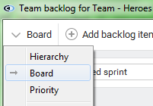

In order to only visualize the backlog items that are associated with a particular PI on the board, select the "Find" feature; located in the top right corner of the board view. Then select the appropriate "PI x" milestone tag to filter out all features that are associated with that particular PI.





In the Board view, make sure that you select *planned sprint* in the "Columns" setting and that *None* is set in the "Lanes" setting.



Below is an example of how a DBT team workspace is visualized in Hansoft.

#### 

#### Sorting board items by type

It is also possible to configure the Board view to sort all the board items by "Type", e.g. *Business Feature*, *Architectural Feature, User Story, etc.*

In order to do this you select *Type* is set in the "Lanes" setting.



Below is an example of how a DBT team workspace sorted by "Type" is visualized in Hansoft.

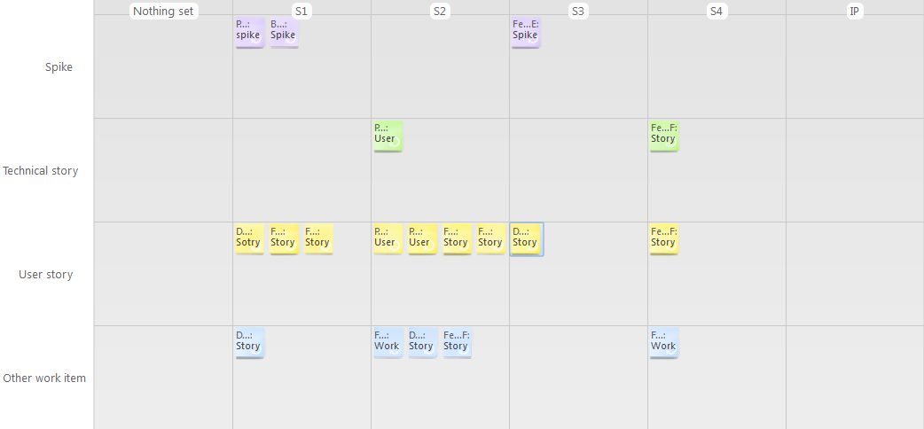

#### Board item color scheme

The color of the board items that are seen in the board view is automatically assigned based on the color schema defined in the "Type" column. The color is only updated for items in the "Type" column that are not customized for a particular project

The following color scheme is defined in for items in the board view:

* Architectural Feature: red
* Business Feature: blue
* Spike: magenta
* Technical Story: green
* User story: yellow
* Other work item: cyan (blue)
* Nonfunctional requirement: orange

**Note**: Do **not** change the color for these entries in the "Type" column in your team project.

Board items that are of a customized *Type* will be visualized with the color orange. Customization of the board view

A main manager for a Hansoft project may do some additional customization to the Board view layout that will affect all project users.

Some of these customizations capabilities are listed here, please refer to the Hansoft manual for a complete description of the board view customization capabilities in Hansoft; [Hansoft v.8 manual](http://www.hansoft.com/manuals/80/English/).

### Customizing the DBT Team workspace size

It is possible to customize the grid size of the board in order to display more items and prevent items from being stacked on the board; if that is not desired. Below is an example of stacked items:

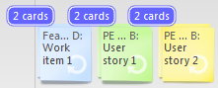

In order to change the grid size, select "Grid size" in the "Settings" drop down menu and define the grid size you want to use

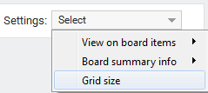

**Note**: Changing the grid size for a board is not a personal setting and affects the layout for the board for the project. This setting is only accessible by a user that is defined as a main manager for the Hansoft project.

### Customizing the information that is displayed on the board item

It is possible to customize the information that is displayed on the board item, e.g. Points, Type, etc.

In order to change add/remove board item information, select "View on board items->Item column data" in the "Settings" drop down menu and check or uncheck the data you want to display.

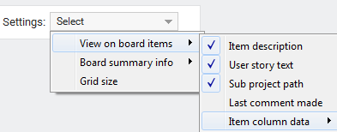

**Note**: Changing the information that is displayed on a board item is not a personal setting and the change will take affect for all users in the project. This setting is only accessible by a user that is defined as a main manager for the Hansoft project.

## General Board view functionality

Some general board view functionalities are listed here, please refer to the official [Hansoft](http://www.hansoft.com/) documentation for a complete description of the board view capabilities.

#### Update backlog item properties

Rearranging board view items on the board will update backlog item properties. Below are two examples with regards to the Board view configuration that was mentioned above.

* If a board item is moved from column S1 to S3, this will update the "Planned Sprint" property for this backlog item.
* If a board item is moved from lane *Business Feature* to *Architectural Feature*, this will update the "Type" property from *Business Feature* to *Architectural Feature* for this backlog item.

#### Zoom and panning feature

The board can be zoomed with the mouse wheel and dragging with the right mouse button will pan-and-scan across the board.

The zoom feature is accessible using the mouse wheel or through the buttons located to the top right in the board view. If there are reports located in the toolbar, the zoom buttons may be located in the extended toolbar menu that is accessed through the button located in the top right corner of the backlog window.

# Program Board in Hansoft

During the RPE the Program board is used to visualize the Program feature delivery in the PI. In Hansoft the backlog "Board view" is used to visualize the Program board for the Program. This visualization is updated automatically based on the plan that each DBT team has produced in their team projects.

**Note**: The "Board view" in the "Agile Schedule" cannot be used.

## Program backlog requirements

In order for the program board to be visualized correctly a number of properties must be set for each backlog item that is part of the PI.

### Milestone property requirements

For the Program project in Hansoft a milestone is created for every PI. The pre-defined naming convention used is "PI x" and the date for the milestone should be the last day of the PI.



Each architectural feature, business feature or spike that exists as a backlog item in the program backlog that is pulled by a team for the PI must be tagged with the "PI x" milestone in the "Milestone tag" property. A rule of thumb is to always ensure that when a team create a link from a milestone in their team project to a feature in the Program, the "PI x" milestone tag should always exists. A feature may already have the "PI x" milestone tag set, e.g. if another team already has pulled the particular feature as part of their PI plan.



**Note**: It's possible to multi-edit backlog items, but this is not recommended to do so for the "Milestone tag" property; unless the backlog items should have identical milestone tags.

The "Milestone tag" property is inherited; this means that if a parent object is tagged with a particular milestone all child objects will inherit the milestone tag. Hence the importance to ensure that only backlog items that are associated with a particular PI is tagged with the "PI x" milestone tag.

### Planned sprint property requirements

The "Planned sprint" property for backlog items in the Program backlog is automatically updated/populated with the planned sprint data from linked team projects. A feature may have deliverables in multiple sprints, which all are seen in the Feature summary. The latest sprint that has the latest deliverable will be populated into the "Planned sprint" property in the Program backlog.



### Feature Lead property requirements

A feature delivery in a PI can require deliverable from either one or multiple teams. In order to be able to visualize the program deliverables per team, the "Feature lead" property must be populated manually. This must be done for all features and the feature lead is the one team that is responsible for the feature delivery in the PI.



Below is an example of the Program board sorted by the "Feature Lead" property:

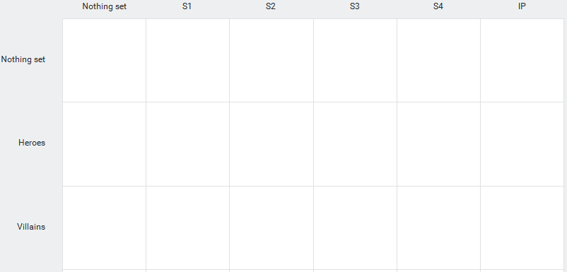

This means that features pulled by several teams will only be visible in the program board by one team. If a team has none or limited representation of their program deliverables in the PI on the program board due to the team not being a feature lead. Then the team reports can be used to show all features that the team will be working on during the PI. The team reports are available in the drop down menu located in the top left corner in the board view window.

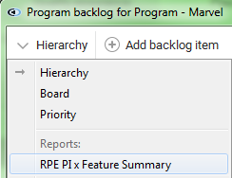

**Note:** There is an individual report for each team that is part of the Program.

The "RPE PI xFeature Summary" report is grouped by the "Type" and "Feature lead" properties and an example of the report output can be seen below:

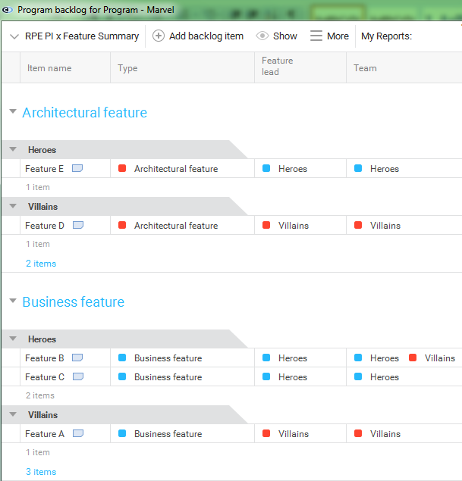

## Visualizing program dependencies

The “RPE PI x - Internal dependencies” report is used to visualize internal dependencies for the features that are planned for a PI. The report list all Program backlog items where there is more than one team working on the feature deliverable. The order of team deliverables can be seen in the "Internal dependencies" column. Where each team name is listed as well as the sprint in which the team deliverable is planned to be completed. The order of the team names in the "Internal dependencies" column is determined by the planned sprint for each team deliverable. If the planned sprint for a team deliverable is not defined by the team, this will be indicated as *(not set)* in the report.

The “RPE PI x - Internal dependencies” report is grouped by the "Type" and "Item name" properties and an example of the report output can be seen below:

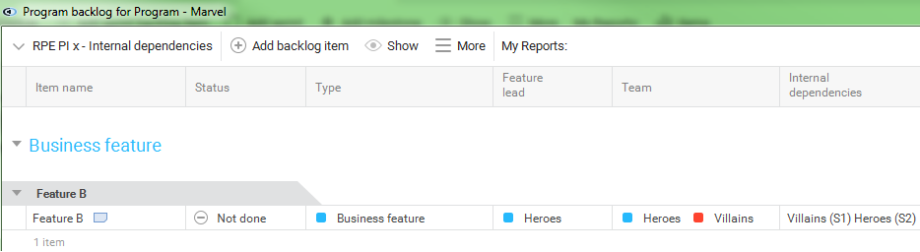

This “RPE PI x - Internal dependencies” report is available in the toolbar in the Program backlog: 

# Inspect & Adapt

At the end of a PI each team will participate in the Inspect & Adapt, I&A, event where teams review the assigned business value assigned and evaluate the achieved business value.

This data is then entered into the Quantitative Measures metric, a learning metric, where the Program can identify if the program or a team is on the "track" with what was planned and what was delivered; see <http://scaledagileframework.com/metrics/> for more details about this metric.

## Quantitative Measures

Each DBT team reviews the fulfillment of the team objectives together with the Product Manager. The fulfillment is determined by the percentage, %, of the objective that was actually completed. This data is then entered into the "Achieved Business Value (%)" column in the "Agile Schedule view" for the Program project Hansoft.

Below is an example of team objectives, assigned "Business Value" and "Achieved Business Value":

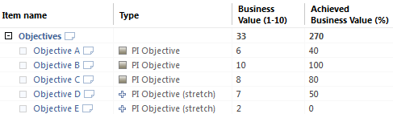

**Note:** Hansoft automatically aggregate numerical values for child objects, hence the Objectives object has a "Business Value" of 33 and "Achieved Business Value" of 270 above.